**2. ReactJS-HOL**

**Home.js**

import React from 'react';

function Home() {

return (

<div>

<h1>Welcome to the Home page of Student Management Portal</h1>

</div>

);

}

export default Home;

**About.js**

import React from 'react';

function About() {

return (

<div>

<h1>Welcome to the About page of the Student Management Portal</h1>

</div>

);

}

export default About;

**Contact.js**

import React from 'react';

function Contact() {

return (

<div>

<h1>Welcome to the Contact page of the Student Management Portal</h1>

</div>

);

}

export default Contact;

**App.js**

import React from 'react';

import Home from './Components/Home';

import About from './Components/About';

import Contact from './Components/Contact';

function App() {

return (

<div>

<Home />

<About />

<Contact />

</div>

);

}

export default App;

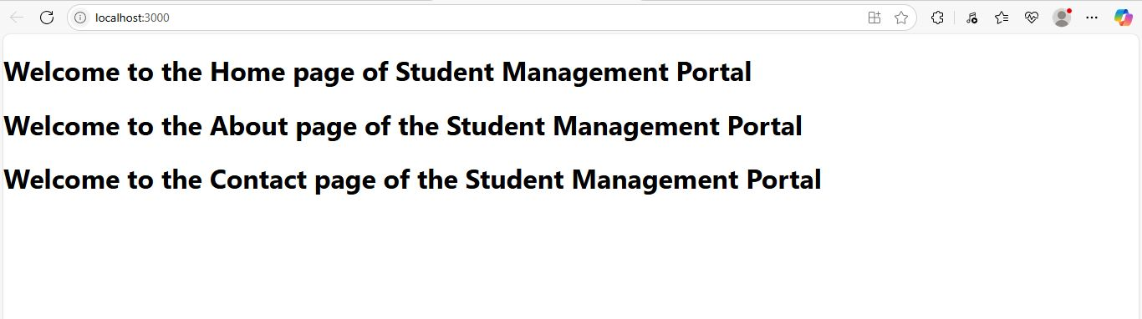

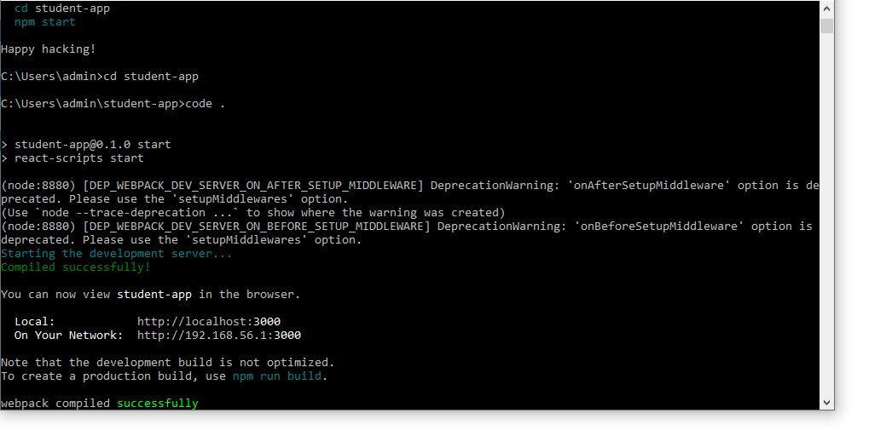

**1. Explain React components**

A **React component** is a reusable, independent piece of code that returns a React element to be rendered to the page. Components allow you to split the UI into smaller, isolated parts.

**2. Identify the differences between components and JavaScript functions**

| **Feature** | **React Components** | **JavaScript Functions** |
| --- | --- | --- |
| Purpose | Used to render UI | Used to execute a task or logic |
| Return Type | Returns JSX (React Elements) | Returns a value or result |
| React Lifecycle | Supports lifecycle methods (class) | No lifecycle |
| JSX Usage | Accepts and returns JSX | Doesn’t inherently support JSX |
| Props Support | Can receive props | Doesn't directly use props |

**3. Identify the types of components**

There are two main types of components in React:

* **Class Components**
* **Function Components**

**4. Explain class component**

A **class component** is a React component defined using ES6 class syntax. It can hold **state**, use **lifecycle methods**, and returns JSX via the render() method.

import React, { Component } from 'react';

class Welcome extends Component {

render() {

return <h1>Welcome to React</h1>;

}

}

**5. Explain function component**

A **function component** is a JavaScript function that returns JSX. Since React 16.8, function components can use hooks like useState and useEffect for state and lifecycle logic.

function Welcome() {

return <h1>Welcome to React</h1>;

}

**Define component constructor**

In a class component, the **constructor** is used to initialize the state and bind methods. It is called once when the component is created.

constructor(props) {

super(props);

this.state = {

message: 'Hello'

};

}

**7. Define render() function**

The **render()** function is required in class components. It returns the JSX to be displayed on the UI.

render() {

return (

<div>

<h1>Welcome</h1>

</div>

);

}